Jonathan Hoover
TLCPL
report: IT Helpdesk ticket analysis

IT Helpdesk Ticket Analysis

Executive Summary

For this project, all helpdesk tickets from http://helpdesk.toledolibrary.org were exported from the server and imported into a python programming environment to analyze the data and answer the following questions:
- How many tickets has each agency submitted?
- What is the average amount of time it takes IT to resolve reported issues?
- How can we use the data to make things more efficient and improve customer service?

Findings

Source: Total Helpdesk tickets from July 25, 2017 to December 30, 2022.

Descriptive statistics:
Total Helpdesk tickets: 7,235 tickets
What was the average number of tickets per agency?
There are 54 agencies that submitted tickets. Therefore, the average number of tickets per agency is approximately 134 tickets.
Who had the greatest number of tickets? And who had the least number of tickets?
West Toledo Branch had the most tickets at a total of 516 tickets. External and Governmental Affairs and Virtual Services has the least number of tickets with just one ticket each.
What are the total number of tickets for each quartile (25%, 5%0, 75%)?
25 percent of the agencies had 28 tickets or less. 50 percent of the agencies had 89 tickets or less. And 75 percent of the agencies had 220 tickets or less.
How long did it take for IT staff to resolve tickets?
The average amount of time it took to resolve tickets is approximately seven days. 50 percent of the tickets were resolved in one day or less. 75 percent of the tickets were resolved in five days or less. The maximum amount of time it took to resolve a ticket is 343 days.
NOTE: This analysis ignored any tickets that took longer than one year to resolve.

*Please see the Chart section for a graph of all tickets per agency.

Map of all TLCPL library locations

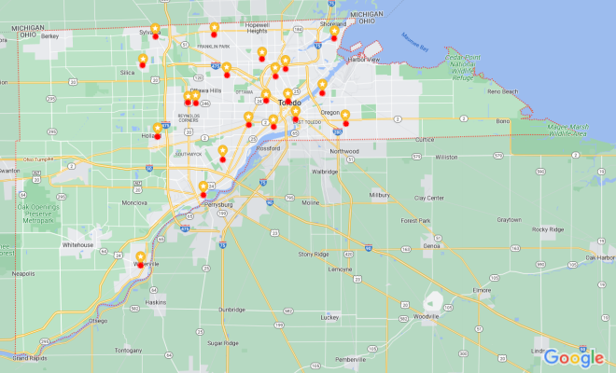

Charts

Helpdesk tickets per agency

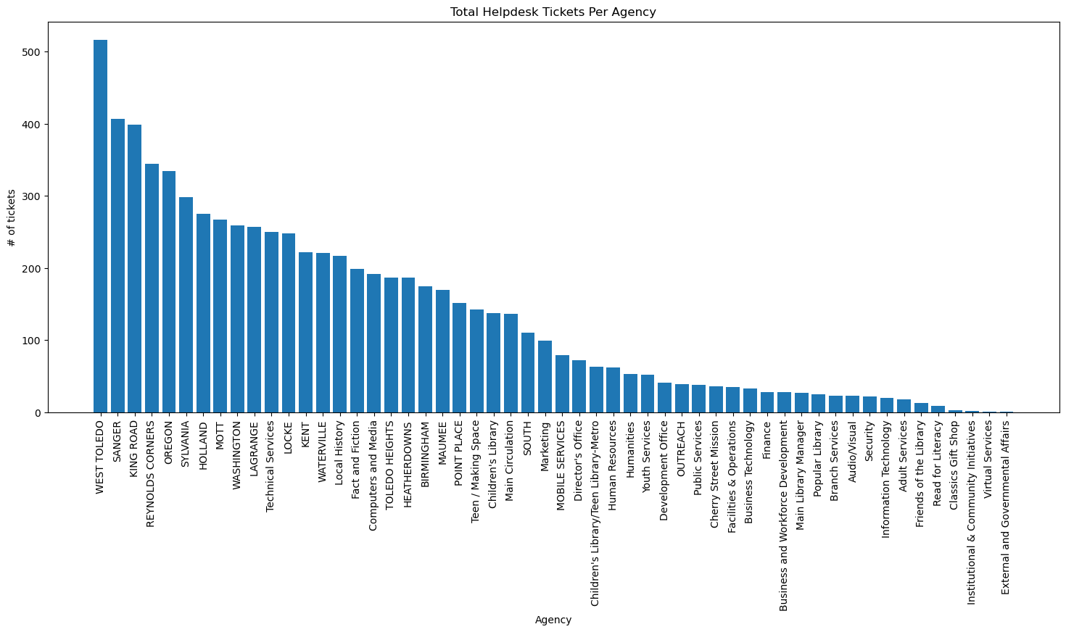
Branch or Department | Total Tickets | Branch or Department | Total Tickets | Branch or Department | Total Tickets
WEST TOLEDO | 516 | HEATHERDOWNS | 187 | Cherry Street Mission | 36
SANGER | 407 | BIRMINGHAM | 174 | Facilities & Operations | 35
KING ROAD | 399 | MAUMEE | 169 | Business Technology | 33
REYNOLDS CORNERS | 344 | POINT PLACE | 151 | Finance | 28
OREGON | 334 | Teen / Making Space | 142 | Business and Workforce Development | 28
SYLVANIA | 298 | Children's Library | 137 | Main Library Manager | 27
HOLLAND | 275 | Main Circulation | 136 | Popular Library | 25
MOTT | 267 | SOUTH | 110 | Branch Services | 23
WASHINGTON | 259 | Marketing | 99 | Audio/Visual | 23
LAGRANGE | 257 | MOBILE SERVICES | 79 | Security | 22
Technical Services | 250 | Director's Office | 72 | Information Technology | 20
LOCKE | 248 | Children's Library/Teen Library-Metro | 63 | Adult Services | 18
KENT | 222 | Human Resources | 62 | Friends of the Library | 13
WATERVILLE | 221 | Humanities | 53 | Read for Literacy | 9
Local History | 217 | Youth Services | 52 | Classics Gift Shop | 3
Fact and Fiction | 199 | Development Office | 41 | Institutional & Community Initiatives | 2
Computers and Media | 192 | OUTREACH | 39 | Virtual Services | 1
TOLEDO HEIGHTS | 187 | Public Services | 38 | External and Governmental Affairs | 1

Helpdesk tickets per physical location

The following shows number of tickets per physical location, which could be used to divide locations into zones and assign these zones to IT technicians. Therefore, all of Main Library’s agencies have been grouped into one location called ‘MAIN’.

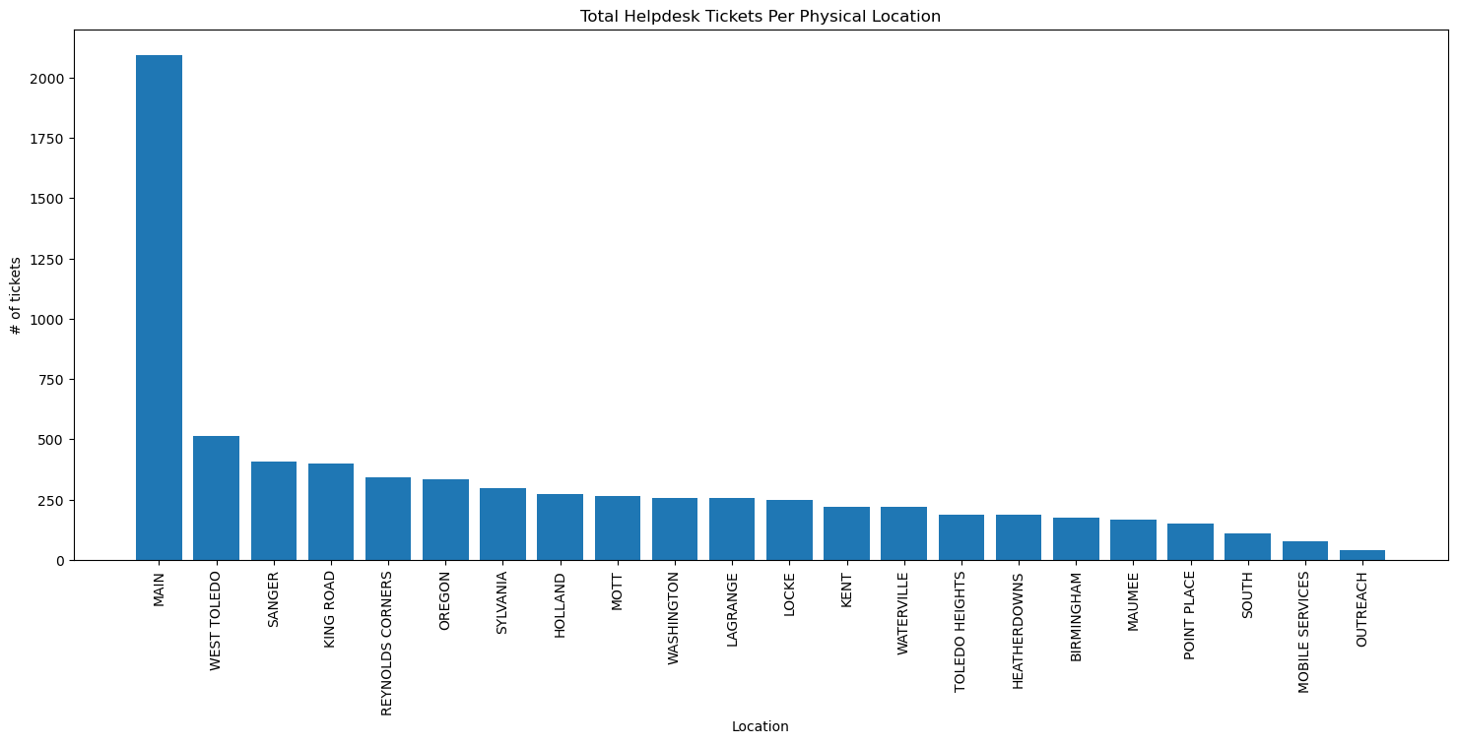

Branch or Department | Total Tickets | Branch or Department | Total Tickets
MAIN | 2095 | LOCKE | 248
WEST TOLEDO | 516 | KENT | 222
SANGER | 406 | WATERVILLE | 220
KING ROAD | 399 | TOLEDO HEIGHTS | 187
REYNOLDS CORNERS | 344 | HEATHERDOWNS | 186
OREGON | 334 | BIRMINGHAM | 174
SYLVANIA | 298 | MAUMEE | 169
HOLLAND | 275 | POINT PLACE | 151
MOTT | 267 | SOUTH | 110
WASHINGTON | 259 | MOBILE SERVICES | 79
LAGRANGE | 257 | OUTREACH | 39

